Lighting Research Summary

Plants grow best under natural daylight which includes everything from infrared to UV Light. LEDs cannot completely imitate this, but we can get close to it by coating it with phosphor to convert one wavelength to a desired wavelength. Different phases of plant growths require different wavelength which we can alter using a software depending on what the plant needs. Our LEDs are designed to be programmable and they are used to meet specific plant needs.

All plants grow best under the spectrum of natural sunlight which includes everything from infrared to UV light. Light Emitting Diodes (LED) made specifically for growing crops on the other hand, does not emit infrared or UV Light. Which makes it one of the best sources of light for growing crops as it does not provide any danger to the plants as infrared emits temperature and too much UV Light can damage the plants. However, this means that our LED cannot completely imitate natural sunlight.

Every LEDs have their own system of measurement called the Color Rendering Index (CRI) which measures the extent to which objects color appear true and accurate under a light source. CRI has a max value of 100, which is natural daylight, and the current best LED is 99 CRI with a value of 95+ being already good enough. CRI Values are calculated using smaller sub scores of R values (each has a max 100) which represents the light sources color rendering ability for a color/ shade. An LED with 99 CRI might look good but most LEDs do not have a strong dark red value in the spectrum, which is what plants really need for growing (Chlorophyll A and B). Natural daylight on the other hand has strong dark red values. To get more red wavelength to be revealed in order to get closer to natural daylight, we incorporate red phosphor in LED manufacturing process to improve its spectral composition and create white light close to natural light. What this phosphor coating does is convert light energy of one wavelength and redistribute it as a different wavelength. This way we get stronger red wavelengths and our LEDs become closer to natural light.

Generally, plants need natural daylight for a balanced growth. Too much of red and blue can increase its growth rate, but its quality might not be the best, so there should be a balance in the spectrum. Therefore, at different growth phases of a plant, the LEDs – using software – can be programmed to emit specific wavelengths of light at different phases of its growth. How much light a plant takes in a day is measured using its Daily Light Integral (DLI) and it terms of time it should average to about 14-16 hours a day depending on the plant.

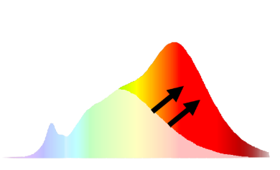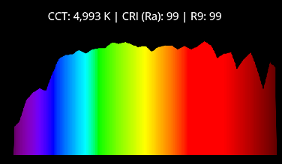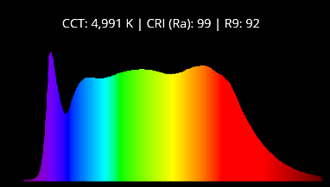

Figure 1: Using Red phosphor we can convert other color wavelengths to get red wavelength

Figure 2: Wavelength of current LEDs with 99 CRI (the best)

Figure 3: Wavelength of natural daylight that we are trying to imitate (has more dark red than LEDs)